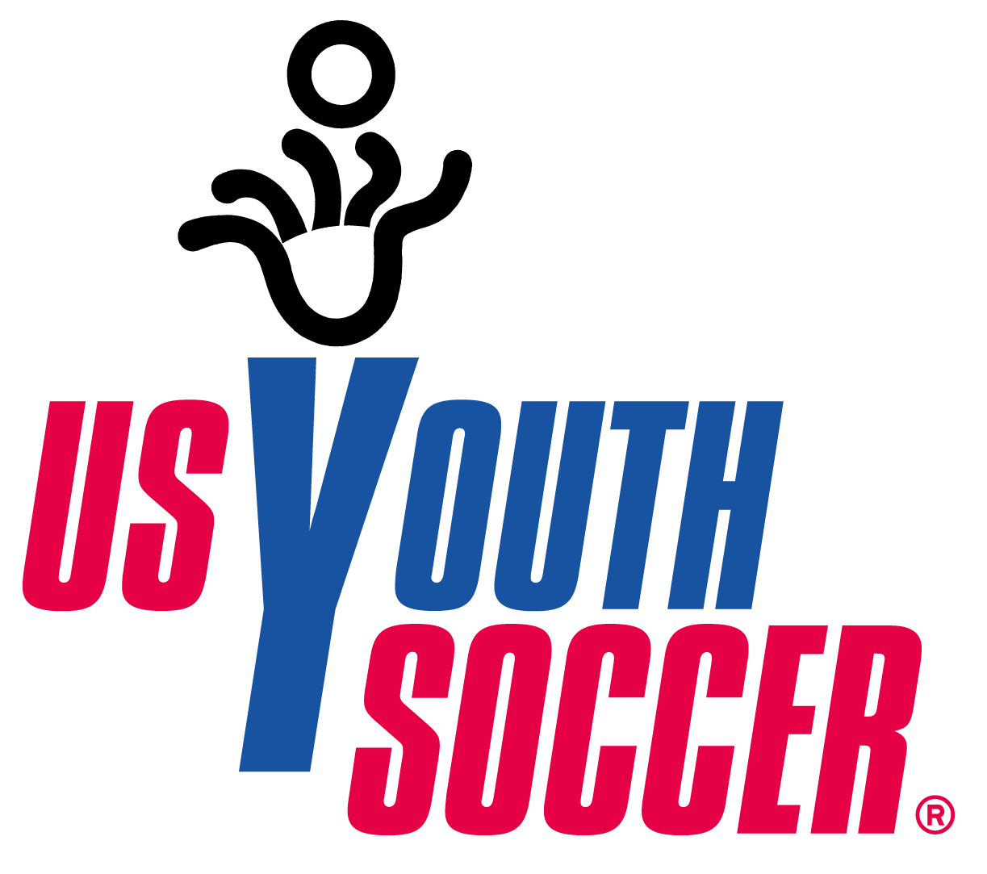


US YOUTH SOCCER
TRAVEL POLICY
(Adopted March 20, 2010)

PART I—GENERAL

Rule 101. PURPOSES AND APPLICATION

(a) This policy is adopted in order (1) to provide State Associations of US Youth Soccer with criteria and procedures in addressing matters related to the travel of teams and their players and team officials to tournaments and games, and (2) to establish a level of standardization.

(b) This policy does not apply to the following:
- the US Youth Soccer National Championship Series and US Youth Soccer National Presidents Cup;
- ODP regional and national events and the ODP Championships; or
- teams participating in a league, approved by one or more State Associations, a region of US Youth Soccer, or US Youth Soccer, in which the teams from State Associations participate and travel from one State Association to another for regularly scheduled league matches.

Rule 102. DEFINITIONS

The following definitions apply to this policy:

(1) Travel: travel by a team and its players and team officials to participate in a
tournament or game that is not a tournament or game approved by the team’s State
Association of US Youth Soccer in that State Association’s territory.

(2) Approved Travel: travel by a team to a tournament or game approved by a State Association of US Youth Soccer such that the benefits of membership in US Youth Soccer and the State Association apply to the tournament or game, and the use of US Youth Soccer member passes and the US Youth Soccer team roster are permitted.

(3) International Tournament or Game: a tournament or game played in the United States that is open to one or more teams from outside the United States and the tournament or game has been approved by US Soccer.

(4) Non-US Youth Soccer Travel: travel by a team to a tournament or game that has
not been approved by US Youth Soccer or any of its State Associations.

(5) Application to Travel Form: the standard form by which a team requests its State Association to approve the travel of a team and its players and team officials to a tournament or game approved by US Youth Soccer or another State Association, with the form including provisions governing the use of guest players, where allowed, to ensure that all participating players and team officials are properly registered with the approving State Association.

(6) Alternate Player Pass: a player pass that may be provided on request for a player on a team for use in traveling to an international tournament or game that has not been approved by US Youth Soccer or any of its State Associations.

(7) Non-US Youth Soccer Team Player Form: the form that may be provided to a team for use by the team and its players and team officials to travel to a tournament or game that has not been approved by US Youth Soccer or any of its State Associations, with the form providing basic information contained on member passes for players and team rosters (e.g., the name and date of birth of players on the team)..

(8) US Soccer: the United States Soccer Federation, Inc.

(9) US Youth Soccer: the United States Youth Soccer Association, Inc.

Rule 103. FUNDAMENTAL PRINCIPLES

The following fundamental principles apply in carrying out this policy:

(1) US Youth Soccer and its State Associations consider the safety of youth soccer players and others involved in youth soccer to be of paramount importance. They have implemented stringent risk management policies and practices to promote the safety and security of their players, teams, team officials, and spectators. US Youth Soccer works in close cooperation with its State Associations to protect and increase the safety of youth soccer players nationwide.

(2) US Youth Soccer and its State Associations’ programs, activities, policies, and bylaws that protect the safety and security of youth soccer players include, but are in no way limited to—
(A) adopting the KIDSAFE PROGRAM, including establishing and training Risk
Management coordinators, and applying the program broadly to team
officials, referees, and volunteers;
(B) promulgating risk management guidelines for youth websites;
(C) encouraging and facilitating compliance with the Children’s Online Privacy
Protection Act;
(D) instituting coach and referee training programs;
(E) developing materials and presenting programs about running safe,
well-managed soccer tournaments and games;

(F) developing and disseminating programs about proper parenting of youth
soccer players;
(G) encouraging and conducting educational programs about positive interactions
among players, parents, team officials, referees, and spectators;
(H) providing information and guidance concerning many safety issues, such as
lightning and weather, goal anchoring and safety, and coordination with local fire,
emergency, and law enforcement officials; and
(I) ensuring age-appropriate interaction between and among youth soccer players.

(3) US Youth Soccer programs, activities, policies, and bylaws do not apply to teams, players, and team officials at tournaments, games, and other programs and activities conducted by soccer organizations that are not members of US Youth Soccer and its State Associations. US Youth Soccer and its State Associations cannot vouch for the safety and security of any tournament, game, or other program or activity conducted by soccer organizations that are not members of US Youth Soccer and its State Associations. US Youth Soccer State Associations are to undertake their best efforts to make their players, parents, team officials, and teams aware of when they are participating in tournaments, games, and other programs and activities conducted by members of US Youth Soccer and its State Associations. This awareness is necessary to ensure that its players, parents, team officials, and teams are not misled to believe that the risk management programs, activities, policies, and bylaws of US Youth Soccer and its State Associations apply to tournaments, games, and other programs and activities not conducted by members of US Youth Soccer and its State Associations.

(4) Each US Youth Soccer State Association has considerable discretion regarding the source, scope, terms, and benefits of its insurance policies and the activities covered under those policies. Each State Association is responsible for negotiating the details of its insurance coverage with its insurance carrier. Each State Association therefore have an obligation, directly and through its members, to inform its players, parents, team officials, teams, its members, and other interested persons about the insurance coverage provided, including what is, and is not, covered by its insurance policies

(5) Parents and youth soccer players who are members of US Youth Soccer and one of its State Associations have a right to know the character and scope of the benefits they receive through their State Association and as a member of US Youth Soccer. The State Association, directly and through its members, should attempt to further educate its players, parents, team officials, teams, clubs, and other interested persons about the benefits they get from their membership in US Youth Soccer and the State Association, including what is, and is not, covered by its programs and activities, insurance, policies, and the relevant bylaws of the State Association and US Youth Soccer.
(6) (A) Except as provided in subparagraph (B) of this paragraph (6), US Youth Soccer
member passes and team rosters issued to players and teams of the members of US
Youth Soccer and its State Associations are for use only when those players and teams
participate in tournaments, games, and other programs and activities of members of
US Youth Soccer and its State Associations. Those passes and rosters refer to US
Youth Soccer and may also refer to the State Association. As a result, their usage at a
tournament, game, or other program or activity may communicate that US Youth
Soccer and its State Associations’ programs, activities, policies, and bylaws,
Including risk management programs and insurance coverage, apply to that
tournament, game, program, or activity. Therefore, US Youth Soccer does not
approve the use of its member passes and its team rosters in connection with
tournaments and games conducted by soccer organizations that are not members of
US Youth Soccer and its State Associations. If a team believes it needs member
passes for players in connection with the team’s participation in an international
tournament or game or a team roster for a tournament or game conducted by soccer
organizations that are not members of US Youth Soccer or its State Associations, US
Youth Soccer or the State Association shall provide an alternate player pass or a
Non-US Youth Soccer Team Player Form, or both, as provided by Rule 303.

(B) US Youth Soccer or a State Association may authorize the use of US Youth Soccer member passes (but not rosters) only for players traveling to participate in an
international tournament or game referred to in subparagraph (A).

(7) US Youth Soccer and its State Associations’ players, team officials, and teams may participate and compete in any tournament, game, or other programs or activities, whether or not they are conducted by members of US Youth Soccer and its State Associations. US Youth Soccer and its State Associations do not and may not inhibit, prevent, or prohibit any of their players, team officials, or teams from engaging in tournaments and games or other programs or activities that are not conducted by members of US Youth Soccer and its State Associations. US Youth Soccer and its State Associations do not and may not discriminate against the participation of players, team officials, or teams on the basis of a player’s, team official’s, or team’s membership in, or association with, another youth soccer organization, and do not and may not interfere with the opportunity of any player, team official, or team to travel to compete in any tournament or game of another soccer organization. Players, team officials, and teams are free to decide in which tournaments and games they want to participate. Approval and waiver of approval only applies to tournaments and games approved by US Youth Soccer or its State Associations, or both, as provided by this policy.

- For a variety of reasons, it may be important for a State Association to be informed about tournaments and games in which its member players, teams, and clubs are participating, even if those tournaments and games are not conducted by members of US Youth Soccer and its State Associations. These reasons may include, but are not limited to—
  - planning and scheduling events, activities, and competitions;
  - being aware, for insurance purposes, in which activities the members are engaged;
  - providing accurate information to its members about programs and activities in which they are participating;
  - providing accurate information in response to inquiries from its members or people involved in or associated with those programs and activities; and
  - monitoring compliance with US Youth Soccer and its State Associations’ programs, activities, policies, and bylaws.
Rule 104. ENFORCEMENT AND PENALTIES

Failure of a player, team official, or team to follow the applicable bylaws and policies of US Youth Soccer, its State Associations, or both, may result in the imposition of penalties by US Youth Soccer or the applicable State Association(s).

PART II—US YOUTH SOCCER TRAVEL

Rule 201. TRAVEL APPROVAL

(a) An application to travel to a tournament or game is to be submitted by a team to the State Association with which the team is rostered. Such an application is only required if (1) the tournament or game is approved by US Youth Soccer or a State Association of US Youth Soccer to which this policy applies, (2) the team is traveling to a tournament or game that is approved by a State Association other than the State Association with which the team is rostered, and (3) waivers provided by subsections (c) and (d) of this section do not apply.

(b) Any application for travel that does not meet the requirements of the bylaws, policies, and rules of US Youth Soccer and the team’s State Association need not be approved. The team must contact its State Association for its specific policies and fees. Any application that is not submitted in a timely manner may be subject to late fees if it is approved. Only a team and its players and team officials who are in good standing with their State Association will be approved for travel.

(c) State Associations may waive the requirements of subsection (a) of this rule or provide for a notice of travel in place of an application to travel.

(d) State Associations may mutually agree to waive the requirements of subsection (a) of
this rule, or provide for a notice of travel in place of an application to travel, for teams to which this policy applies that are playing in any tournament or game approved by US Youth Soccer or a State Association. A team participating in any such tournament or game must follow procedures its State Association has approved.

(e) All State Associations shall recognize the travel procedures and application travel approval form of US Youth Soccer that have been adopted by the State Association regarding the travel.

(f) The State Association approving or permitting travel shall indemnify and hold the
host State Association and US Youth Soccer harmless from all claims related to or arising from the travel, including defense costs and attorney fees associated with such claims.

(g) State Associations shall publish and make available their travel approval policies, consistent with this policy. State Associations also will make available their travel approval forms and notices they utilize in place of the approval forms.

(h) US Youth Soccer will, in cooperation with its State Associations, post links on its website to the travel policies of each State Association.

Rule 202. REQUIRED DOCUMENTS FOR APPROVED TRAVEL

In addition to any requirements a State Association has with regard to travel for a team and its players and team officials, US Youth Soccer requires the following documents to be available for review by the organization hosting the tournament or game for which the team’s travel has been approved:
(1) a copy of the approving State Association’s application to travel approved by the
State Association if the State Associations requires such approval;
(2) a validated roster, or copy thereof, as issued in the manner approved by the team’s
State Association;
(3) a member pass approved by the State Association, for each player, guest player, and team official listed on the approved roster and traveling with the team. Each member pass for a player must include the team information, the valid seasonal year, the player’s name, and the player’s verified birth date as required by Rule 204 of the US Youth Soccer Policy on Players and Playing Rules;
(4) an authorization properly executed with required signatures for each player to allow emergency medical treatment;
(5) copies of any required permissions for a coach or player listed as a guest; and
(6) emergency contact information.

Rule 203. INTERNATIONAL TRAVEL OUTSIDE THE UNITED STATES

(a) International travel outside the 50 states of the United States and the District of Columbia by teams of US Youth Soccer State Associations and members of State Associations shall comply with the requirements of US Youth Soccer, the team’s State Association, and US Soccer. Copies of all applications to US Soccer for international travel shall be sent to the State Association at, or prior to, the time the application is submitted to US Soccer.

(b) In addition to any form and fees required to be submitted for approved travel under this policy, US Soccer requires its approval for a team’s travel outside the United States, and it has procedures, additional document requirements, and a fee that must be submitted, by its deadline prior to that travel. Consult US Soccer for the current requirements, procedures, and fees.

PART III—NON-US YOUTH SOCCER TRAVEL

Rule 301. APPROVAL NOT REQUIRED

Participation in tournaments and games that have not been approved by US Youth Soccer and its State Associations is Non-US Youth Soccer Travel. Players, team officials, and teams may participate and compete in those tournament and games and do not need approval or permission from US Youth Soccer or their State Associations to do so.

Rule 302. NOTICE OPTION

(a) A State Association may require reasonable notification, if it deems it necessary, from any team and its players and team officials seeking to participate in Non-US Youth Soccer Travel tournaments and games. A State Association may only require notification that is reasonable to fulfill its needs (see Rule 103(8) of this policy), such as scheduling a team for participation in other programs or activities, knowing for insurance purposes in which programs and activities State Association members are participating, providing accurate information to its members about programs and activities in which they are participating, providing accurate information in response to inquiries from people involved in or associated with those programs and activities, and monitoring compliance with US Youth Soccer and State Association programs, activities, policies, and bylaws.

(b) The failure to provide proper notification as required by the applicable State Association may result in the imposition of penalties by the State Association. However, those penalties, if any, must be reasonable, and may not prevent or prohibit a player, team official, or team from participating in any program or activity that is not a program or activity of a member of US Youth Soccer or its State Associations, except to the extent provided by US Soccer bylaws and policies.

Rule 303. MEMBER PASSES AND ROSTERS

(a) (1) US Youth Soccer does not approve the use of its member passes and rosters in connection with tournaments and games conducted by soccer organizations that are not members of US Youth Soccer and its State Associations.
(2) If a team believes it needs to provide the information contained in member passes for players in connection with that team’s participation in an international tournament or game conducted by soccer organizations that are not members of US Youth Soccer or its State Associations, US Youth Soccer or the State Association shall provide alternate player passes at no cost or current member passes for players participating in such an international tournament or game. The alternate player pass provides the basic information found on member passes and will enable players, team officials, and teams to participate in Non-US Youth Soccer Travel without creating the misimpression that those tournaments or games are approved by US Youth Soccer or any of its State Associations. The information provided on alternate player passes will indicate that the players are currently registered players in good standing with a member organization of US Youth Soccer.
(3) If a team believes that it needs to provide information contained in a team roster in connection with the team’s participation in a tournament or game conducted by soccer organizations that are not members of US Your Soccer or its State Associations, the State Association shall also provide that information by means of a separate form—a Non-US Youth Soccer Team Player Form.
(4) US Youth Soccer and its State Associations willingly provide this information in furtherance of their mutual goal of promoting the sport of soccer and the spirit and intent of US Soccer bylaws and policies.

(b) The restrictions of this rule are necessary to prevent the misimpression that Non-US Youth Soccer Travel is approved by, or associated with, US Youth Soccer or its State Associations or that US Youth Soccer and its State Associations’ safety and risk management efforts are applicable to programs and activities associated with that travel. It is important to accurately communicate to players, team officials, and teams which programs and activities are programs and activities of US Youth Soccer or its State Associations, or both.

Rule 304. MISREPRESENTATION

No person, group, or entity shall, by affirmative misrepresentation or by the failure to disclose material facts, mislead any other person, group, or entity into believing that travel to, or participating in, a tournament or game not approved by US Youth Soccer or any of its State Associations has been or is approved by US Youth Soccer or its State Associations.

